Warrior Foundation Inc.
www.fearlesswarriorfoundation.com
Fearless Warrior Foundation offers a one-time financial scholarship for graduating Wantagh High School Seniors or Wantagh district resident attending private high school. Award recipients would embody the person who goes beyond the norm, with high regard for integrity, generosity, and kindness.

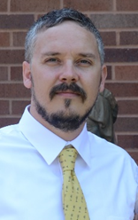
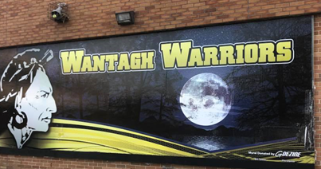
In honor of Bill Towey, Class of 1994, The Towey Family created a legacy of funding to promote integrity among young people in the next generations. My brother, Bill, has been a positive part of the daily life at Wantagh High School for many years, perhaps without people knowing it. He helped design and paint the Wantagh Warrior mural on the side of the main building, the students pass every day. At 40, Bill fought a brave battle against Stage 4 Colon Cancer for nearly two years. On June 5, 2018, we sadly said goodbye to this young husband and father.

He was generous and kind to everyone he encountered. His passions for fishing and graphics, a great love of his family and friends were highlights of his short life. One steadfast character trait was he always did the right thing for the entity of life.
Inspired by the Warrior spirit, the mural, and my brother's endurance these past few years, we created the Fearless Warrior Scholarship in his honor.

The Fearless Warrior Scholarship

The Fearless Warrior Scholarship promotes ethics and integrity among young people's academic, social, and spiritual lives.
We are looking for students who demonstrate a positive influencer who has acted selflessly and shown to help others in need without expected gratitude or repayment.

Scholarship Availability

- $500 Scholarship money is for college tuition or post-secondary education expenses. Minimum one per year - Award prizes are subject to change based on available funding. Each qualifying student is eligible to receive a non-renewable compensation once.
- Applications can be submitted from November 1 through May 15.

Scholarship Eligibility
Enrolled in 12th grade in Wantagh High School or Private school (Wantagh district resident) and completed application and a 500+ word typed essay.

